DonorExpress



For Fundraising Success

Welcome to DonorExpress Fundraising Software

DonorExpress Users Manuel

The DonorExpress Users Manuel is designed to assist you with questions you may have about using DonorExpress Fundraising Software and to be used as a training aid. In the event you need further assistance, please give us a call at (828) 264-2577, we’ll be happy to help you find the answer. Thank you for trusting DonorExpress Software for your fundraising needs.

Index

Menu Options on the Main Menu Page 5
Donations Page 5
Reports Page 5
System Maintenance Page 5

Change Password Page 5

Admin Tools Page 5

Security Page 5

Organization Information Page 5
Batch Donations Page 5

Export Donor Transactions Page 5

Letters and Mailings Page 5

Simple Criteria Export Page 6
Merge Duplicate Records Page 6

Browse Pick List Page 6
DonorExpress Custom Reports Page 6
Data Source Linking Page 6
Help Page 6
Donor Help System Page 6
Registration Page 6
About DonorExpress Page 6
Features on the Donor Entry Screen Page 6
Donor Entry Page 6
Right Mouse Click Page 6
Contact Data Tab Page 7
Additional Info Tab Page 7
Donations Tab Page 7
Donations Entry Screen Page 8
Acknowledgments Lists Page 9
Pledge Tab Page 10
Pledge Entry Screen Page 10
Pledge Payment Scheduling Screen Page 10
Donor Pledge Payment Schedule Screen Page 11
Groups Tab Page 11
Notes Tab Page 11
Correspondence Tab Page 12
Control Panel Page 12
Navigation Buttons Page 12
Search Button Page 12
All Button Page 13
Find Button Page 13
Delete Button Page 13
Add Button Page 13
Save Button Page 14
Cancel Button Page 14
Menu Bar Page 14
Acknowledgement List Page 14
Donor Profile Page 14
Donor Browse Page 14
Filter By group Page 14
Features on the Report Selection Screen Page 15
Report on the Selection Screen Page 15
Campaign Reports Page 15
Donations Reports Page 16
Labels - Avery5160 Page 16
List Reports Page 17
Memorial Donations Reports Page 17
Pledge Reports Page 18
Analysis Reports Page 18
System Table Maintenance Options Page 19
Campaigns Page 19
Donation Type Page 19
Payment Type Page 19
Payment Terms Page 19
Donor Groups Page 20
Update Letters Page 20
Update Donor Levels Page 20
Acknowledgement List Page 20
Features on the Admin Tools Menu Page 21
Security Page 21
Security Options Page 21
User List Page 21
Security Entry Page 21
Organization Information Page 21

Batch Donations Page 22
Export Donations Transactions Page 22
Letters and Mailings Page 22
Create Donations Letters Page 23
Select Letter to Print Page 23
Create List Page 23
View List Page 23
Export List Page 23
Stamp Letter Date Page 23
Create Acknowledgments Letters Page 23
Select Letter to Print Page 23
Create List Page 24
View List Page 24
Export List Page 24
Stamp Letter Date Page 24
Simple Criteria Export Page 24
Create List Page 25
View List Page 25
Export List Page 25
Donor Correspondence Page 25
Group Export Page 25
Browse Pick List Page 26
Sort Page 26
Find Page 26
Filter By Selection Page 26
Remove Filter/Sort Page 26
Duplicate Donor Merge Page 26
Custom Reports Page 26
Data Source Linking Utility Page 26
Features on the Help Menu Page 27
Donor Help System Page 27
Registration Page 27
About DonorExpress Page 27

Menu Options on the Main Menu

Donors: The Donors Option on the Main Menu allows user to access all Donor and Donation information. The Donor screen will allow adding, viewing or editing the Donor Demographic information, Donations, Pledges, Grouping, Notes on the Donor and all Correspondences that have been sent to the Donor.

Reports: DonorExpress Report Selection screen allows the user to select from stock reports or labels and set specific criteria for Donor/Donation reporting. Depending on the report, fields will become available to enter additional information.

System Maintenance: System Maintenance feature allows the user to maintain the DonorExpress support tables to fit into their accounting and business needs. These support tables include tables like Campaigns, Donation Type, Payment Type, Response Letters and Donor Levels.

Change Password: Change Password allows the user the ability to change his or her password as needed. Only the currently logged in users User Name is provided.

Admin Tools: Admin Tools allows the users with proper security to access the following Administrator functions:
- Security option allows the user to add or edit user names, passwords and users security level.
- Organization Information option allows the user to view or edit organization information. This information is used as report headers.
- Batch Donation Entry allows the user to create multiple donation records at one time for donors who give a consistence gift on a consistence date.
- Export Donor Transactions allows the user to create and export a file with donation information that can be imported into compatible accounting systems. This data export file was specifically designed for the CYMA Accounting for Windows Not-For-Profit Edition.
- Letters and Mailings allows the user to create the Donation Response Letter and Acknowledgment Letter file for used with Microsoft Word to create response mailings.
- Simple Criteria Export: The Simple Criteria Export feature allows the user the ability to utilize simple querying to export Donor or Donation Data for special reports or mailings.
- Browse Pick List allows the user to pick and choose random Donors and group them for reporting and/or exporting.
- Merge Duplicate Records allows the user to merge the information from one donor record into another donor record and delete the first record. This feature is designed to help with duplicate records.
- DonorExpress Custom Reports allows the user to run custom reports that have been created by Tailored Systems, Inc. for them.
- Data Source Linking allows the user to re-link to a different database.
Help: The Help options are where the user can go to find answers to problems with features or procedures.
- Donor Help System: Donor Help System allows the user to access the instructional DonorExpress help files.
- Registration: Registration feature is where users enter the registration number for DonorExpress licensing and check on the number of days remaining on their current DonorExpress license.
- View Data Path allows the user to view the path to the data file the application is linked to.
- About DonorExpress: About DonorExpress gives information about the version and build number of DonorExpress that is currently installed along with Vendor Information.
Exit: Allows the user the ability to exit the application.

Features on the Donor Entry Screen
Donor Entry: This is the main location to enter or edit Donors, Donations and Pledges. When a Donor is added, the top fields are for the donor’s Salutation, First Name, Middle Name and Last Name along with the Organization Name if it applies. The current date is captured as the Date Added and by default, new Donor is indicated as an active Donor by the Active check box. Donors are made Inactive instead of Deleted so their information is there for historical reporting purposes.
Right Mouse Click: The right mouse click button is available to use on the Contact Data Tab and on the Additional Data Tab, you can Find, Sort Ascending, Sort Descending, Filter By Selection, and Remove Filter/Sort. The Find is specific to the field that the cursor is located in at the time the right mouse button is clicked. The Sort Ascending feature automatically sorts the records in the selected field in ascending alphabetic order. Sort Descending sort’s records in the selected field automatically by descending alphabetic order. The Filter by Selection is used to filter records by the field that is highlighted for the same information in the fields. Remove Filter/Sort includes all the
records on file and returns all the records to view.

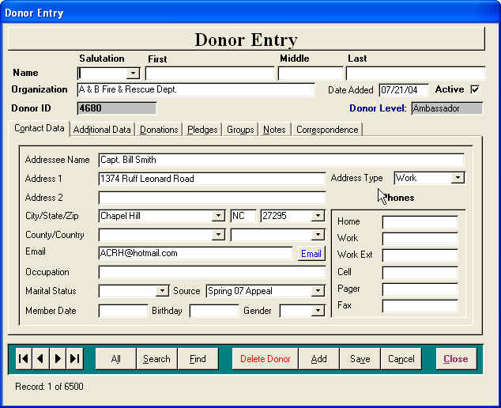
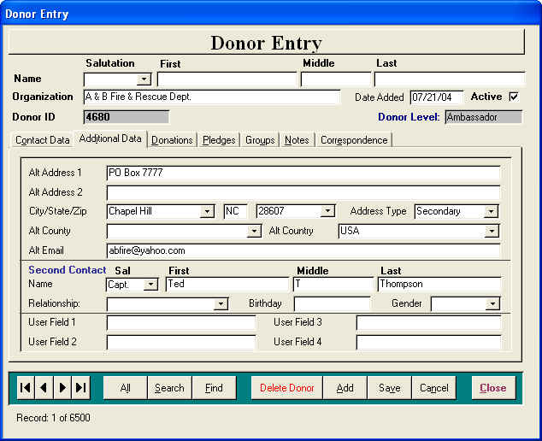
Contact Data Tab: Displays Donors main demographic information and the main address fields used for mailings. The Addressee field will allow the user to customize how the donor’s name will appear on the labels and mailings. The Address Type field is an information field used to prompt the user as to the type of address (Business or Home) that is referenced. The Member Date is designed to be used for tracking memberships but can be used for any date the user wants to track. The Source field is used to track the how the original contact with the donor occurred.

Additional Data tab displays additional Donor demographic information such as a secondary address and Internet E-mail address. There is also fields for the user to include a Secondary Contact for the donor along with the relationship they have to the donor. This tab also has 4 User Defined fields that may be used any way the user would like.

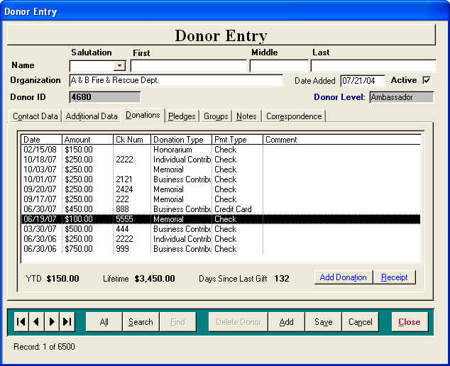
Donations Tab: The Donations Tab is a descending (most recent donation at the top) list view of the Donors Donation History. Information on any donation may be viewed by double clicking on the desired donation to open the Donation Entry Screen to that record. The user can create a new donation record by selecting the Add Donation Button to open the Donation Entry Screen ready to enter the donation. Selecting a donation from the list and clicking the Receipt Buttton will print a receipt for the selected donation. At the bottom of the tab is a running total for the donor’s Year-To-Total, Lifetime Total and How long since their last donation. To delete a donation, view the donation and delete from the donation screen.

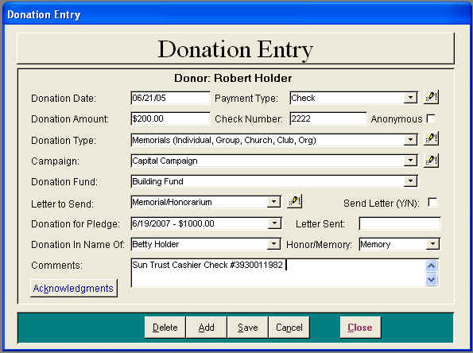
Donations Entry Screen: The Donor Entry Screen is accessed through the Donations Tab on the Donor Entry Screen. The first field is the Donation Date, which defaults to the last date entered but can be changed to any date. The + and – keys on the keyboard will increase or decrease the date one day at a time. If the current date is correct simple Tab to the next field which is the Payment Type field. This field defines how the donation payment was made. Note: If the payment type you need is not on the pull down, click the Update Payment Type Button to the right of the field to open the Payment Type Update Screen to edit the Payment Type List. Tab next to the Donation Amount field where the amount is entered. This field is formatted to currency so the cents do not need to be entered if they are 00. Tab next to the Check Number field to record the check number if it applies. Tab next to the Donation Type field where the donation can be associated with a Donation Type for Accounting purposes. The Donation Reports use this field to group the donation as to the source of the donation. Note: If the Donation Type you need is not on the pull down, click the Update Donation Type Button to the right of the field to open the Donation Type Update Screen to edit the Donation Type List. Tab next to the Campaign field where the donation can be associated with a Campaign if it applies so DonorExpress can track the progress of the Campaigns. Note: If the Campaign you need is not on the pull down, click the Update Campaign Button to the right of the field to open the Campaign Update Screen to edit the Campaign List. Tab next to the Campaign Fund field to designate a Fund the donation is to be applied to. Tab again to the Donation Letter to Send field where you tell DonorExpress which response letter you want to send the donor for this donation. Note: If the Donation Letter you need is not on the pull down, click the Update Donation Letter Button to the right of the field to open the Donation Letter Update Screen to edit the Donation Letter. To the right of the Donation Letter to Send field is the Send Letter Check Box that is checked by default so the donor will receive a Response letter. If a donor gives a donation but does not want to receive any response mailings, Uncheck this box and the donor will not be selected for a response mailing. The next field is the Donation for Pledge (red indicates active pledge) field that allows the user to select a pledge made by the donor and associates this donation with that pledge. Tab to the Letter Sent field that is a field we will fill in later after response letters have been mailed showing the date the letter was sent. Tab to the Donation In Name Of field where we handle the Honorarium and Memorial donations. The name of the honoree is entered here in a format that is acceptable to appear on all response or acknowledgment correspondences. Below the Comments Label is the Acknowledgments Button that is used to send Acknowledgment Letters to the family of the honoree. This will be discussed in detail later. The final field is the Comments field that allows the user to enter any comments they want to make about the donation.
Acknowledgments List:
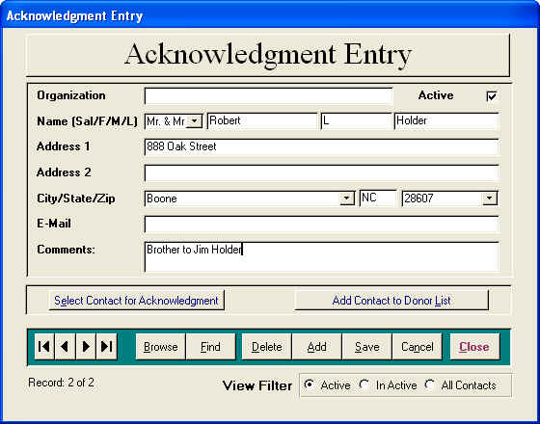
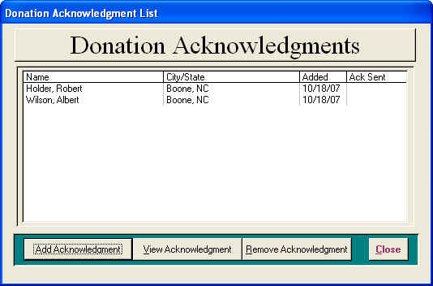
Acknowledgments are where the user can select friends and family of the honoree to receive an Acknowledgment Response Letter notifying them that a donation has been received in the name of a loved one. To add a person to the list of acknowledgments, select the Acknowledgments List Button from the Donation Entry Screen, which will open the Acknowledgment List Screen. The Acknowledgment List Screen will show everyone selected for an acknowledgment response letter. If this screen is blank, no one has been select. If this person has had family acknowledged previously, then click the Check Previous Acknowledgment Button on the Menu Bar at the top of the screen. This will open a screen that shows all contact that was previously acknowledged for this person. Double click the names on the to add a person to the list. To create a new acknowledgment record, click the Add Acknowledgment Button to open the Acknowledgment Entry Screen. We use this screen to enter a person’s demographic information and add them to the acknowledgment list. To add a person to the list, first click the Browse Button on the Acknowledgment Entry Screen to see if the person is already on the acknowledgment table. If the person is on the table, double click their name on the Browse Screen to open the Acknowledgment Entry Screen to their record. Next click the Select Contact for Acknowledgment Button to add that contact to the list. If the contact is not in the acknowledgment table, simple add their information and click the Select Contact for Acknowledgment Button and add them to the list. From this screen you can Browse and Add all contacts that need to be acknowledged. Also from the Acknowledgment Entry the user can create a Donor Record for this contact by simply clicking the Add Contact to Donor List Button. Once all contacts have been added to the Acknowledgment List, close the Acknowledgment Entry Screen. To remove a contact from the Acknowledgment List, select the contact to be removed and click the Remove Acknowledgment. To view a contact’s information from the Acknowledgment List, select the contact and click the View Acknowledgment Button or double click the contact’s name to open the Acknowledgment Entry Screen to that contact record. Once all Acknowledgment Contacts have been added, click the Close Button to return to the Donation Entry Screen. Acknowledgment Entry screen can be reached 3 ways:
- From the Donor Entry Screen – Menu option
- From the System Maintenance option on the Main Menu
- From the Donation Acknowledgment screen – Add Acknowledgment button
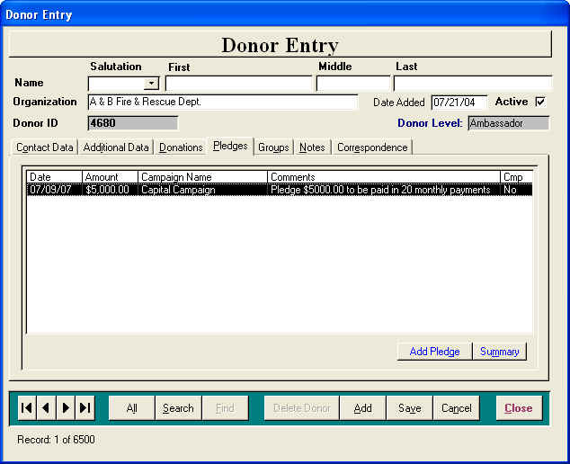
Pledge Tab: The Pledge Tab allows the user to view the pledge history for the donor and create a Summary Report to track the progress of a pledge. To view detail information on a pledge, double clicking on the desired pledge bringing up the Pledge Entry Screen to that record. To Add a new pledge, click the Add Pledge Button to open the Pledge Entry Screen ready to add a new record. To create a Summary Report, select the Pledge to be reported on and click the Summary Button.
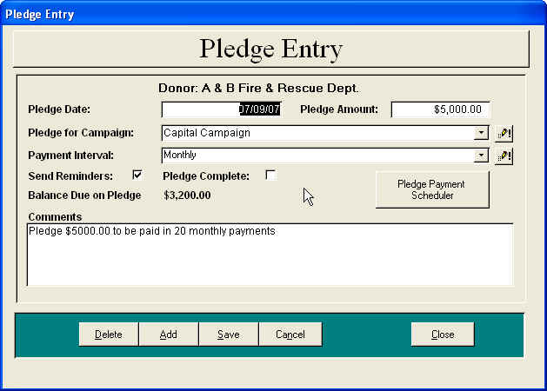
Pledge Entry Screen: The Pledge Entry Screen allows the user to create a pledge by entering the pledge date, the pledge amount, the campaign that generated the pledge, the method of payment and any comments about the pledge. The user can also check the Send Reminder checkbox if the donor would like reminder notices sent when a pledge payment is due. Note: If the Campaign or the Payment Period you need is not on the pull down, click the Update Campaign Button or the Update Payment Period Button to the right of the field to open the Update Screen to edit the Campaign or Payment Period table. Once a Pledge has been created, it will be available on the Pledge field on the Donation Entry Screen. Once the pledge has been completed, the Pledge Complete should be checked and the pledge will no longer be on the pledge pull down on the Donation Entry screen.
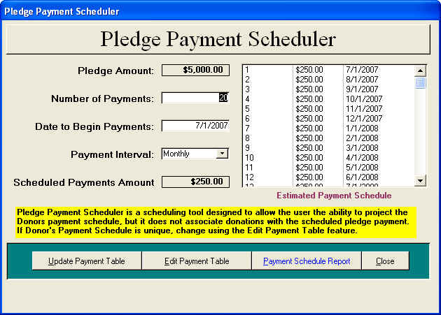
Pledge Payment Scheduling Screen: The Pledge Payment Scheduling Screen allows the user to create a schedule for the donor’s pledge payments after the pledge has been created. From the Pledge Entry Screen, select the Pledge Payment Scheduler button to open the pledge scheduler. This screen displays the pledge amount, allows the user to enter the number of payments and payment interval. After the information is entered, the scheduler displays the projected schedule. If the projected schedule is correct, click the Update Payment Table button to create a payment record for the donor. Note: The user must click the Update Payment Table button to create the payment schedule. The pledge payment schedule may be edited at any time by clicking the Edit Payment Schedule button to bring up the Donor Pledge Payment Schedule Screen.
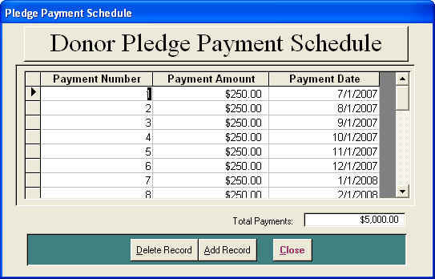
Donor Pledge Payment Schedule Screen:
The Donor Pledge Payment Schedule screen will allow the user to edit the payment schedule. This will allow the user to customize the payment amounts and dates. Go to the Reports Selection Screen, then choose the pledge function in the select report type and select the pledge reminder report that will then pull from this schedule table for the pledge reminder mailings. The Pledge Schedule Report is a printable report that can be mailed to the donor showing their payment schedule.

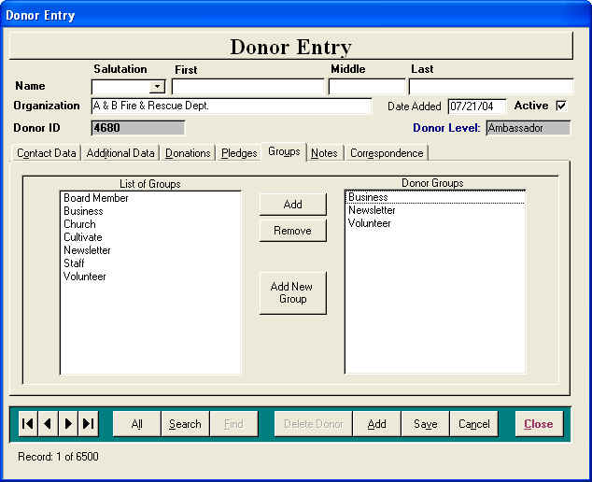
Groups Tab: The Groups Tab is where you would associate the Donor with a particular group or groups. Donors can be associated with more than one group. This allows you to print mailing labels or a report for all Donors in a group. The list to the left is the available groups while the list on the right is the list of groups the donor has been assigned to. To assign a group to a donor, either double click the group name in the List of Groups or select the Group and click the Add button. Similarly, you can double click the group in the Donor Groups list or select the Remove button to remove the Donor from the group. Note: If the Group you need is not on the list, click the Add Group Button to open the Update Screen to edit the Groups table.

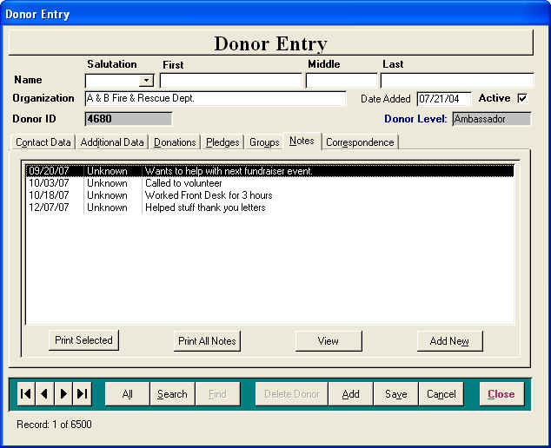
Notes Tab: The Notes Tab is where the user can record any Comments or Notes about the donor. To enter a new note, select the Add New Button to open the Donor Note Screen ready to enter a new note. To View an existing note, select the note in the list and choose the View Button or double click on the note you wish to view. The Print Selected Button will create a printable report for a selected note while the Print All Notes Button will create a printable report for all notes. To delete a note, view the note and delete from the Notes screen.
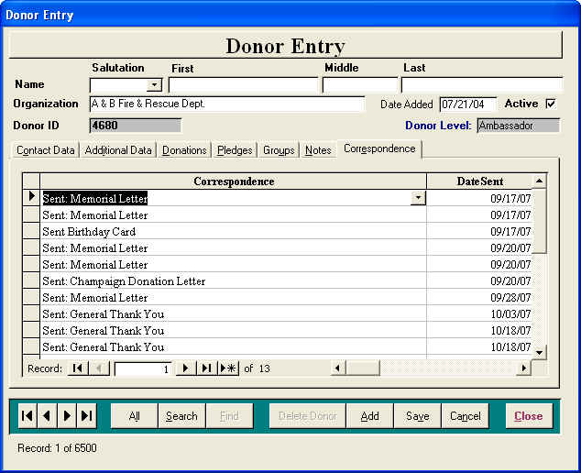
Correspondence Tab: The Correspondence Tab is a listing of all correspondence that has been sent to the donor. You can create a correspondence record several ways. The user can manually enter a correspondence record and date on the Correspondence Tab by selecting a letter from the pull down or typing any appropriate letter description. The user can create a correspondence record when Donation Letters are exported from the Admin Tools / Letters and Mailing option. This creates a Response Letter entry on the donor’s Correspondence Tab. The user can create a correspondence record when Acknowledgment Letters are exported from the Admin Tools / Letters and Mailing option. This creates an Acknowledgment Letter entry on the donor’s Correspondence Tab and an entry on the Acknowledgment Contact’s record. The user can also create a correspondence record from the Simple Criteria Export Screen from the Admin Tools / Letters and Mailing option. This creates a User Defined Letter entry on the donor’s Correspondence Tab.

Control Panel: The Control Panel at the bottom of the Donor Entry screen are controls that allow the user to perform various functions.
Navigation Buttons: First Record, Previous Record, Next Record, Last Record allows the user to navigate the Donor records one record at a time.

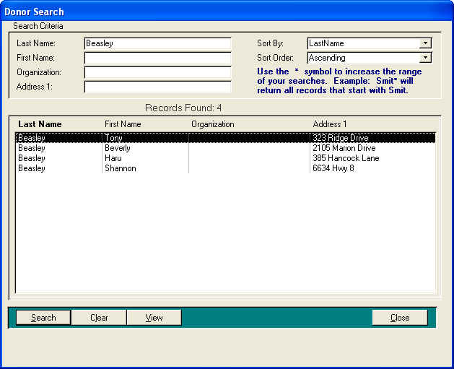
Search Button: The Search Button will open the Donor Search Screen, which is a multi criteria search screen that enables the user to locate a donor’s record in a fast and easy manner. The user can enter one or more criteria values in the fields and select the Search Button to view one or more records that fit the search results. You can use the wild card * at the end of the value in the criteria field for a wider search. For example if you entered into the Last Name field Smi* the result list box will display all donors that last name started with Smi. To go to a Donor record, either double clicking on the Donor record in the result list box or select the Donor record and select the View button. To clear a previous search and start over, select the Clear button. The result list box can be sorted various ways with the use of the Sort By and Sort Order. When a donor’s record is accessed from the Criteria Search Screen, some of the Navigation buttons are no longer visible because the Donor Entry form is in a filtered state looking at only one record. Click the All Button to remove the filter or return to the search screen to find another donor record.
Note: If the Criteria Search Screen Code has a problem interpreting an apostrophe. Please substitute an asterisk for an apostrophe in the criteria fields. Example: use Smith*s Hardware in the place of Smith’s Hardware.

All Button: The All button will remove the any filters that were created when donor’s record is selected from the Search Screen mentioned above,. This makes all Donor records available for view.

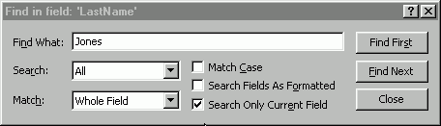
Find Button: The Find Button allows the user to do a find or search on any single field on the screen. Click on the field that you would like to search on (Last Name for Example) and then click the find button to open the Find dialog screen. Enter in the text to find (Smith for Example) and the Find dialog screen will locate the first Donor record that matches your criteria. If this is the right record, close the Find Dialog
screen; otherwise, select the Find Next to go to the next record until correct record has been located. The Wild Card * can be used in the Find Dialog to help with searches. The text Smi* would search for all records that start with Smi and what ever follows.
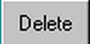
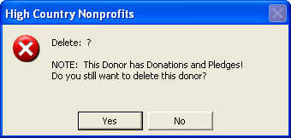
Delete Button: The Delete Button is available only to users with Administrator security rights. If you have security to delete a Donor, this button is enabled. If the Donor has donations, donation acknowledgments, pledges, notes or correspondence records, they will all be deleted along with the Donor record. A delete confirmation screen comes up requiring you to answer Yes or No before the delete will occur.

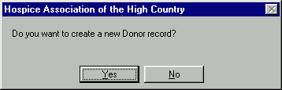
Add Button: The Add Button allows you to enter a new Donor record. By default, the Date Added is today’s date and the Active indicator is set to Yes (checked).

Save Button: The Save Button will save any changes made.

Cancel Button: The Cancel Button will cancel or undo any changes since the last Save event.

Close Button: Will close the Donor Entry Screen and return to the Main Menu.

Menu Bar: The Menu Bar at the top of the Donor Entry screen is controls that allow the user to Browse the Database, Print the Donor’s Demographics and access the Acknowledgment Table.
Acknowledgement List: Allows the user to quickly access the people on their Acknowledgement List. If you know a person is on the Acknowledgement table and you want to add them as a donor, Click the Acknowledgement List selection to bring up the Acknowledgement Entry Screen. Browse for the person to be added to the donor list and when there record is displayed in the Acknowledgement Entry screen, click the Add Contact to Donor List button. This will make a donor record for this contact using the existing contact information.

Donor Profile: Allows the user to create a printout of the donor’s demographic information for the record the user is currently on.

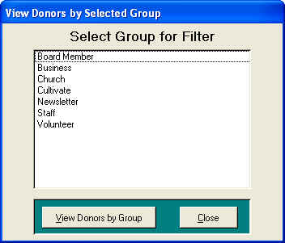
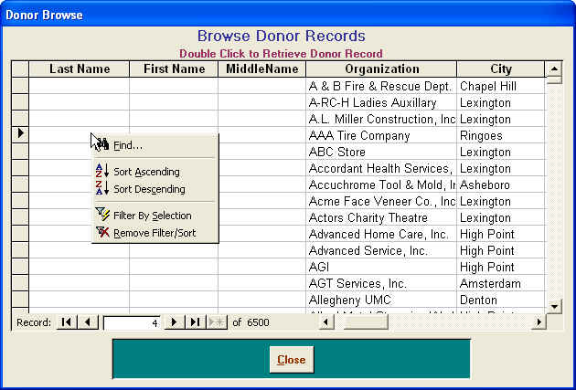
Donor Browse: The Donor Browse is another way for the user to locate a donor’s record. The browse is a listing of all contacts in the donor database. Once the donor has been found on the list, double click on the name to open the Donor Entry Screen to that contact’s information. As with the Browse Pick List, the right mouse button has a pop-up menu that will allow the user to Sort by a selected field, do a Find on a selected field or create a filter for a selected value.

Filter By Group: The Filter By Group feature allows the user to filter the Donor Entry screen to contacts that belong to one group. The Donor Entry screen will display the filter group name at the bottom of the screen and give a count of the member of that group.

Features on the Report Selection Screen

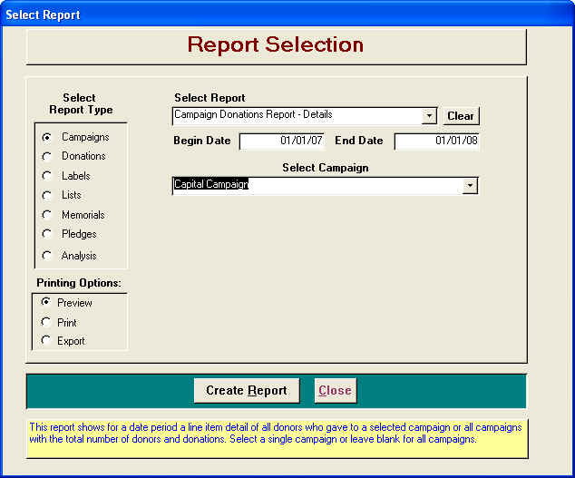
DonorExpress Report Selection screen is used to select reports and set specific criteria for Donor/Donation reporting. To use, 1) Select the type report, 2) Select desired report from available reports displayed in pull-down. The user will be prompted for any additional criteria required for the report. Dates are required if requested. If the report is for only one day, then the same date is entered in both Begin and End Dates. All other report criteria that are requested are optional. For example, if the requested reporting field is the Donor and you select Joe Smith from the Donor pull-down, the report will only contain data on Joe Smith. If you leave the reporting field blank, then the report will contain all Donors. The Printing Option gives the user the choice to Preview the report before printing, send the report directly to the printer or selected reports can be exported to Excel for Mailings. Preview is the default setting for printing. If a report is displayed in preview, the report can still be printed from the print icon on the toolbar while in preview mode. Label selection is given a sort option. You can print the labels by last name or by zip code order; the default sort is Last Name. All reports can be published to Microsoft Word or Excel if the user would like to change the format or do further analysis on the report data. To publish the report to Word or Excel, select the Microsoft Icon on the tool bar.

Reports on the Selection Screen
Campaign Reports
Campaign Donations By Group
This report shows for a date period a line item detail of all donors who gave to a selected campaign or all campaigns and are a member of a group with the total number of donors and donations. Select a single campaign or leave blank for all campaigns.
Campaign Donations Report – Details ***can be exported***
This report shows all donors and their donations received for a selected campaign or all campaigns with the total number of donors and donations.
Campaign Donations Report – Summary
This report shows all donations received for a selected campaign or all campaigns sorted by the donation type with the total number of donors and donations.
Campaign by Funds Detail Report
This report shows all donors and their donations received for a selected campaign or all campaigns and sorted by funds with the total number of donors and donations.
Funds by Campaign Detail Report
This report shows all donors and their donations received by Funds for a selected campaign or all campaigns with the total number of donors and donations.
Summed Campaign Donations by Date ***can be exported***
This report shows for a date period the sum of their donations to a selected campaign sorted with the largest donors at the top down to the smallest donor with the total number of donors and donations.
Donations Reports
Donation Statements - Active Donors ***can be exported***
This report creates for a date period a one page Donation Statement for each donor who gave during that period that shows by month a line item of each donation the donor has given. This report may be run for a single donor or leave blank for all donors.
Donations and Pledges Received Detail Report
This report shows for a date period a line item detail of all donors who gave a donation and/or made a pledge and/or made a pledge payment with grand totals for each column.
Donations By Day
This report shows all donations received for a date range and sorted by the day the donation was received with total donations for each day.
Donations By Donor Type – Detail
This report shows a Detailed report of all donors and donations received for a date range and sorted by the donation type with total donors and donations.
Donations By Donor Type - Summary
This report shows a Summary report of all donations received for a date range and sorted by the donation type with total count and totals of donations.
Donations By Donor Name
This report shows all donations received for a date range and sorted by a selected donor or all donors with total donations.
Donations By Donation Fund
This report shows all donations received for a date range for a selected Donation Fund. This report is independent from the campaign.
Donations By Group
This report shows all donors and donations received for a date range and sorted by a group or all groups with total donors and donations.
Donations By Organization
This report shows all donations received for a date range and sorted by an Organization or all Organizations with total donations.
Donations By Payment Type
This report shows for a date period a line item detail of all donors/donations sorted by Payment Types with the total count and donations.
Donations Deposit Slip By Payment Type
This report shows for a date period a line item detail of all donors/donations sorted by Payment Types and Day with the total count and donations.
Summed Donations By Date ***can be exported***
This report shows sums all donations received from a donor for a date range and sorted by donations totals starting with the largest.
Labels – Avery 5160
Donation Statement Labels
This report creates Avery 5160 Labels to match the Donor Statements for a date period .
Labels – Acknowledgment List
This report formats all contacts addresses on the acknowledgment list into the Avery 5160 format.
Labels - Active Donors
This report formats all active donor addresses into the Avery 5160 format ready to print.

Labels – Avery 5160 (cont)
Labels - Campaign Donors
This report creates Avery 5160 Labels for all donors who gave to a selected Campaign
Labels – Donors By Groups
This report formats all active donor addresses for a selected group into the Avery 5160 format.
List of Donors
List -Duplicate Donors - Donor Name
This report shows possible duplicate donors where the Last Name and Address1 are the same.
List -Duplicate Donors - Organization
This report shows possible duplicate Organizations where the Organization Name and Address1 are the same.
List - Active Donors By the Date Added
This report shows all active donors and their demographic information for a selected date range when they were added to the system and sorted by last name.
List - Acknowledgment List
This report shows all contacts on the Acknowledgment List and their demographic information sorted by last name.
List - Active Donors By Groups
This report shows all active donors and their demographic information for a selected group and sorted by last name.
Publication List of Donors By Donation Date
This report shows a list of all donor names that gave during a date range.
Publication List of Donors By Campaign
This report shows a list of all donor names that gave during a date range toward a selected campaign or all campaigns.
Publication List of Donors Who Gave In The Name Of Someone
This report shows a list of all donor names that gave during a date range toward a selected Honoree or all Honorees.
Publication List of Donors By Donation Type
This report shows a list of all donor names that gave during a date range and sorted by the Donation Type
Memorial Donation Reports
Memorial Donations
This report shows all donors and their donations received for a selected date range and a selected Honoree or all Honorees with the total number of donors and donations.
Memorial Donations-Detail
This report shows all donors, their mailing address, their donations and all people that were acknowledged for the donation. This report allows the user to select the date range for the report and a selected Honoree or all Honorees with the total number of donors and donations.
Memorial Detail – Family
This report shows all donors and their mailing address for donations received for a selected date range and a selected Honoree or all Honorees that can be given to the family to respond accordingly.
Previous Honorarium or Memorial Donations ***can be exported***
This report is designed to show all donors who previously gave in honor or memory of someone.

Pledge Reports
Estimated Pledge Payment Forecast Report
This report shows for a date period a line item detail of all pledge payments that have been collected and then projects what each donor is scheduled to contribute in the next year, 2nd year and 3rd year with totals.
Outstanding Pledge Statements ***can be exported***
This report creates a one-page statement for each donor that shows, the amount pledged and the amount paid toward the pledge along with the outstanding balance.
Pledge Acknowledgments Report ***can be exported***
This report shows all donors who pledge money during a selected date range with the total number of donors and donations. This report can be used to send thank you letters for the pledge.
Pledge Projection Report
This report shows for a date period a line item detail a Projection of the Pledge Payments that are due from a donor from the pledge payment scheduler during the period with total counts and amount totals.
Pledge Reminder ***can be exported***
This report creates a list of donors and their demographics that have a payment date scheduled within the dates specified.
Pledge Reminder Statement
This report creates for a date period a one page Pledge Reminder Statement for all donors that have a Pledge Payment due during the selected period. This Statement shows Pledge Amount, list of payments, next payment and the total balance due.
Pledge Reminder Statement Labels
This report creates matching Avery 5180 Mailing Labels for the Pledge Reminder Statements.
Pledge Report By Campaign
This report shows all donors and the amount pledged for a campaign or all campaigns with the total donors and pledges.
Pledge Status By Campaign ***can be exported***
This report shows all donors, the amount pledged and the amount paid toward the pledge for a campaign or all campaigns with the total donors and pledges. This report also shows the outstanding balance between the amount pledged and the amount paid.
Analysis Reports
Donors By Giving Levels

This report totals all donations from a donor during a date period and lists them in the Donor Level that their giving falls into. The Donor Levels are set in the System Maintenance feature. Export Available after report has been run on Report Toolbar.
Donors By Giving Levels By Campaigns

This report totals all donations from a donor during a date period to a campaign and lists them in the Donor Level that their giving falls into. The Donor Levels are set in the System Maintenance feature. Export Available after report has been run on Report Toolbar.
Donors Giving Last Period/Not This Period

This report will show a line item list of all donors who have given a donation during the selected date period But has not given since the Ending Date. The report shows the donor along with the date and amount of their last gift.

System Table Maintenance Options
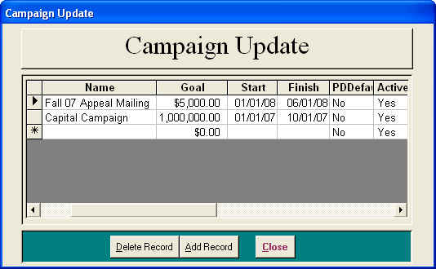
Allows the user to maintain the DonorExpress support tables. The following maintenance tables are available for user maintenance.

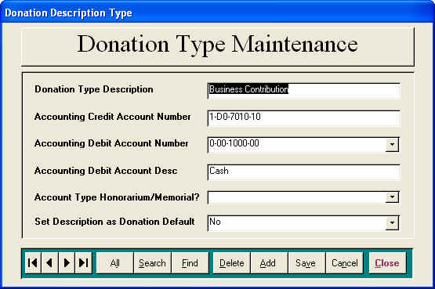
Campaigns: Allows the user to add, edit or remove Campaigns. Information on Campaigns includes campaign name, goal, start and stop dates. A Campaign must be created for it to be available on the Donation screen. You can designate the default Campaign to be displayed when adding a new Pledge or Donation by selecting Yes in the Default field. A Campaign cannot be removed is it has Pledges or Donations associated with it.

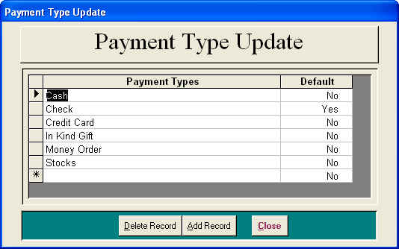
Donation Type: Allows the user to add, edit or remove Donation Types (Memorials, Gift In Kind, etc.). If you export Donations to an accounting system, you can associate credit and debit account numbers to the Donation Type. The credit and debit fields are optional for using DonorExpress. You can designate the default Donation Type to be displayed when adding a new Donation by selecting Yes in the Default field. A Donation Type cannot be removed is it has Donations associated with it.

Payment Type: Allows the user to add, edit or remove Donation Payment Types. You can designate the default Payment Type to be displayed when adding a Donation by selecting Yes in the Default field. A Payment Type cannot be removed is it has Donations associated with it.
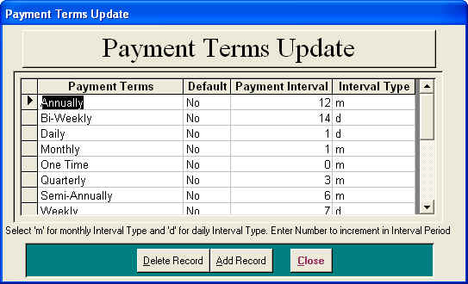
Payment Terms: Allows the user to add, edit or remove Donation Payment Terms. The Payment Interval and Interval Type are used to calculate the pledge payment schedule. You can designate the default Payment Term to be displayed when adding a new Pledge or Donation by selecting Yes in the Default field. A Payment Term cannot be removed is it has Pledges or Donations associated with it.

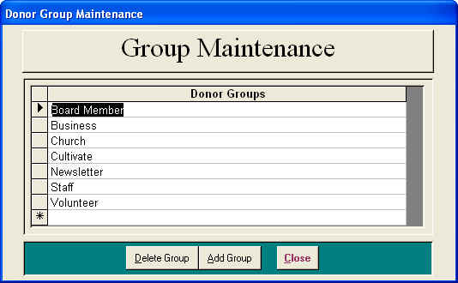
Donor Groups: Allows the user to add, edit or remove Groups. A Group is used to associate Donors to a particular label like Mail Letter, Volunteers, etc. By grouping Donors, you can select them as a whole and create labels for a mailing or just find out who is in the group. A Group cannot be removed is it has Donors associated with it. You assign Donors to Groups in the Donor Entry Screen under the Groups tab. You can also update the Groups Maintenance table from this screen.
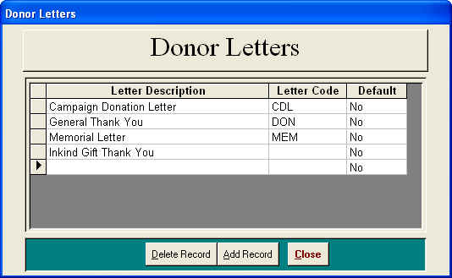
Update Letters: Allows the user to add, edit or remove Letters. You associate Donors Donations to Letters you wish to send them acknowledging their Donation. You can designate the default Letter to be displayed when adding a Donation by selecting Yes in the Default field. A Letter cannot be removed is it has Donations associated with it.

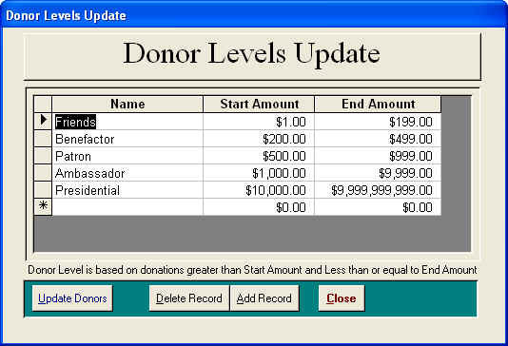
Update Donor Levels: Allows the user to set up a table with donation ranges with titles that is used with the Donor Levels Report. This report sums the donor’s gifts for that date range and sorts them by their giving level.

Acknowledgment List: Allows the user to add, edit or remove Acknowledgments. Acknowledgments are associated with Donors Donations. If you’d like to send a letter acknowledging a Donation to someone other than the Donor, you have to enter an Acknowledgment record for them. If you remove an Acknowledgment, the associations this Acknowledgment has with Donor Donations will also be removed. See the Acknowledgments help section for more information about this process.

Several of the maintenance tables allow the selection of the default value to be displayed within DonorExpress. Here is how that works: when working with the Donation Letters Maintenance table, if you enter Yes in the Default field for a letter, when you enter the Donations form, this letter will automatically be the default letter and be entered each time you create a new Donation. If all records in the maintenance table have No entered in the Default field, when a new Donation record is created, no default value will be entered for the field.

Features on the Admin Tools Menu
Security: Allows the user with the proper security clearance the ability to add or edit user names and their security level.
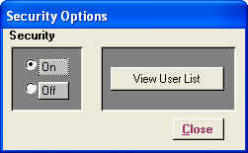

Security Options: Allows the user to turn security on or off and access the User List Screen.

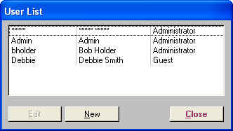
User List: Allows the user to select an existing user or create a new user and open the Security Entry form to make the entry or edit.

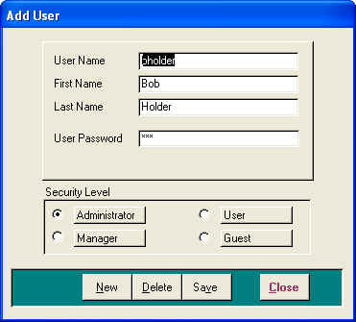
Security Entry: Allows the user to enter user information like user name or login, actual first and last name, password and set their security level. Security levels are: 1) Admin has all rights 2) Manager has all rights except can not change security and delete records 3) User has same rights as Manager except can not change Systems Tables and export Donation Transactions 4) Guest may view only limited information but can not change or add any information.
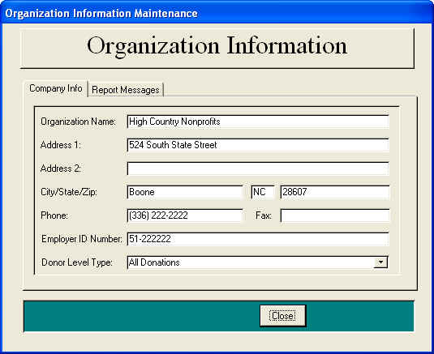
Organization Information: Allows the user to edit organization information that was entered during the initial DonorExpress install. The Company Name is used as the Report Title in many DonorExpress reports. The Organization’s Tax Employer ID Number is also entered here to appear on the receipt.

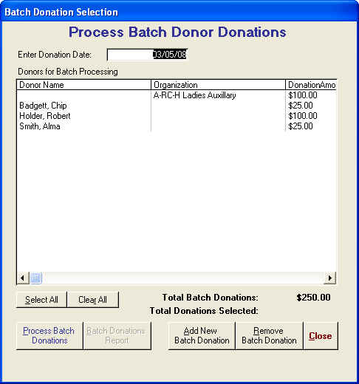
Batch Donations: The Batch Donations (from the Admin Tools) allows the user to set up a batch for donors that give donations on a regular schedule like an employee payroll deduction gift or for scheduled pledge payments. Once the batch is created, the user can select all donors or selected donors to create a donation record for with the donation date entered at the top of the screen. To create a donation entry for the batch, select either the donors to be processed and click the Process Batch Donations button. Clicking the Batch Donation Report button can create a printable report on the results of the batch donations.
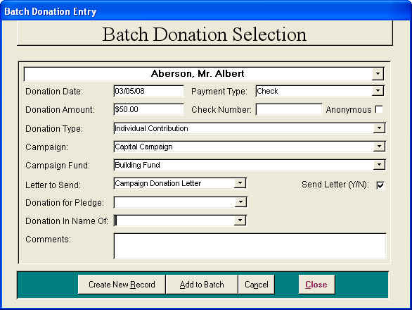
To add a donor to the batch, select the Add New Batch Donation button to bring up a screen similar to the Donation Entry Screen called the Batch Donation Selection. Select the donor from the pull-down at the top of the screen and enter the donation information below. A donor can be removed from the Process Batch Donor Donations Screen by selecting the donor and clicking the Remove Batch Donation Button.

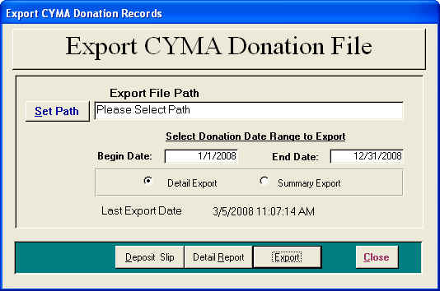
Export Donations Transactions: Allows the user to create and export a file with monthly donation information. This data export file was specifically designed for the CYMA Accounting for Windows Not-For-Profit Edition. First you create an export file by selecting the Set Path button. This brings up a Windows Common Dialog box for entering a file name and file path. Then you need to select the month and year of the Donation transaction date. Choose the Export button to create an export file in the location you designated. Only after you have created an Export file will the Report button become visible.
The export Report will display all Donation transactions for the month/year selected. Because this export is designed for the CYMA Accounting system, only transactions with credit and debit accounts entered in associated Donation Type will be exported. However, ALL transactions will appear on the report.

Letters and Mailings: The Letters and Mailings will allow the user to create an export file for Donation letters sent to Donors, Donation Acknowledgments and/or miscellaneous Donors as selected through a querying process. Please note the yellow box at the bottom of the screen. You’ll find instructions about each field/option as you tab though the fields. The following describes the options available:

Create Donations Letters:
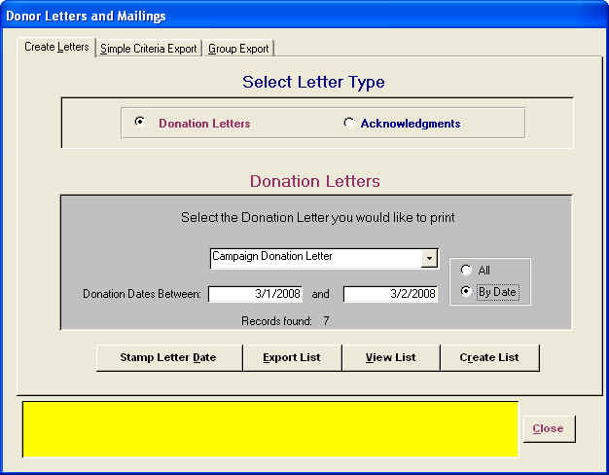
- Select Letter to Print: Choose the Donation Letters option to create an export file for recent Donations. Note: Only Donations with Send Letter checked and an entry in the Donation Letter to Send will be selected. Only letters needing to be printed will be displayed in the pull-down.

- Create List: Choose the Create List to gather all the Donors with the chosen letter. The number of Donors found will be displayed.
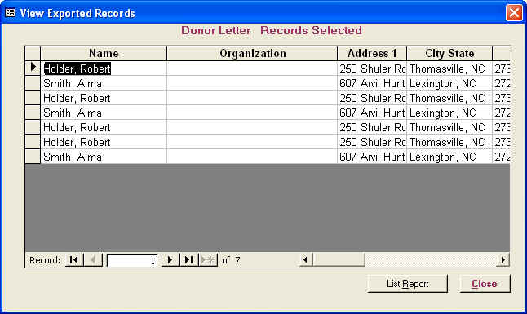
- View List: Choose the View List to see un-editable view of the Donors to receive this letter. A report on these donors can be created from this screen by selecting the List Report Button. Organizations that are using hand written letters can use this report for names and addresses.

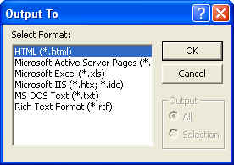
- Export List: Choose the Export List to export the Donors information to an external file. The user will first be prompted as to what format they would like the export file. For a mail merge, select the text, rich text or Excel options. Next the user will be prompted as to the location where the file will be written. There will be a reminder message to remember to stamp the donor’s correspondence record.

- Stamp Letter Date: Choose Stamp Letter Date to document on the Donor’s Correspondence record the date and the type donation letter that was sent. When the user selects this option they will get two messages. The first will ask “Update Letter Sent Date?” This process will also un-check the Send Letter option on the Donation record and stamp the letter sent date. When the user performs this function, it clears this letter type and is ready for the next mailing. If you leave the Send Letter box check, it will be available for selection until un-checked. The next question is “Do you want to create Donor Correspondence records for this list?”. This will create a Donor correspondence record for the Donation Letter send along with current date.

Create Acknowledgments Letters

- Select Letter to Print: Choose the Acknowledgments option to create an export file for recent Donation Acknowledgments. Note: Only Acknowledgments that have not been date stamped will be found.
- Create List: Choose the Create List to gather all the contacts that need an Acknowledgments letter. The number of contacts found will be displayed.
- View List: Choose the View List to see un-editable view of the contacts to receive this letter. A report on these donors can be created from this screen by selecting the List Report Button. Organizations that are using hand written letters can use this report for names and addresses.
- Export List: Choose the Export List to export the contact information to an external file. The user will first be prompted as to what format they would like the export file. For a mail merge, select the text, rich text or Excel options. Next the user will be prompted as to the location where the file will be written. There will be a reminder message to remember to stamp the Acknowledgment Letter Sent Date.
- Stamp Letter Date: Choose Stamp Letter Date to document on the Donor’s Correspondence record the date and the type donation letter that was sent. When the user selects this option they will get two messages. The first will ask “Update Acknowledgment Sent Date?” This process will stamp the contact’s record with acknowledgment letter sent date. When the user performs this function, it clears this letter type and is ready for the next mailing. The next question is “Do you want to create Donor Correspondence records for this list?”. This will create a Donor correspondence record for the Acknowledgment Letter send to the contact along with current date.

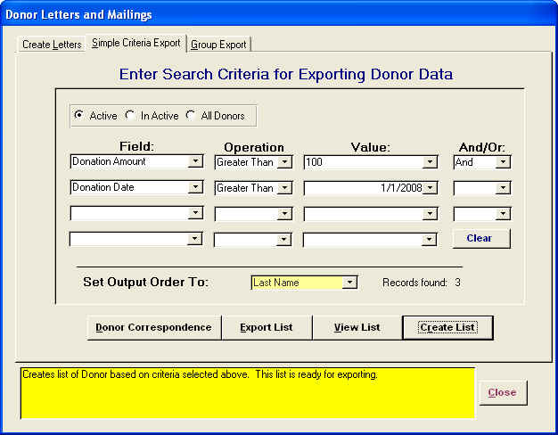
Simple Criteria Export: The Simple Criteria Export allows the user to ask questions of the database and create an export file that can be used reporting, mail merge, etc. With this screen and a little practice you can ask simple questions of the donation database for reports or mailings. Lets say that your director wants you to do a special report or mailing to all donors who have given a donation of over $100.00 since the first of the year. If this is a mailing, you can stamp this mailing in all the Correspondence History for the donors by clicking the Donors Correspondence Button.

- From the Simple Criteria Export Screen in the first Field select DonationDate from the pull down
- Tab to the Operation Field and select Greater Than.
- Tab to the Value Field and enter 01/01/2008.
- Tab to the And/Or and select And to add the second part of our question.
- Tab to the Second Field select DonationAmount from the pull down.
- Tab to the Operation Field and select Greater Than or Greater Than or Equal to if you want to include the amount entered.
- Tab to the Value Field and enter 100.
- Create List: Choose the Create List to pull all the donors that fit the criteria. The number of contacts found will be displayed.
- View List: Choose the View List to see un-editable view of the contacts. If this query is for a report on these donors, select the List Report Button for a quick report.
- Export List: For a mailing choose the Export List to export the contact information to an external file. The user will first be prompted as to what format they would like the export file. For a mail merge, select the text, rich text or Excel options. Next the user will be prompted as to the location where the file will be written. There will be a reminder message to remember to stamp the Acknowledgment Letter Sent Date.
- Donor Correspondence: Choose Donor Correspondence to document on the Donor’s Correspondence record the date and the type donation letter that was sent. When the user selects this option they will get a screen that will allow them to select a correspondence type from the list or create a new correspondence type. This will create a Donor correspondence record for the mailing along with current date.
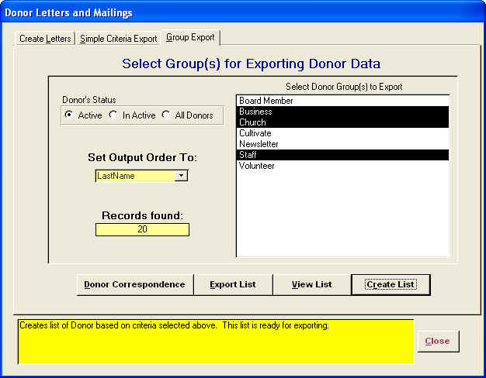
Group Export: The Group Export allows the user to select one or more random groups to be exported for reporting and mailings. This list will include the contact name only one time even if the contact is in more than one selected group. Click to select the groups you want to export and the click Create List . Then the user will have the options to View the list or Export the list. A donor correspondence record can also be created if this is a mailing.

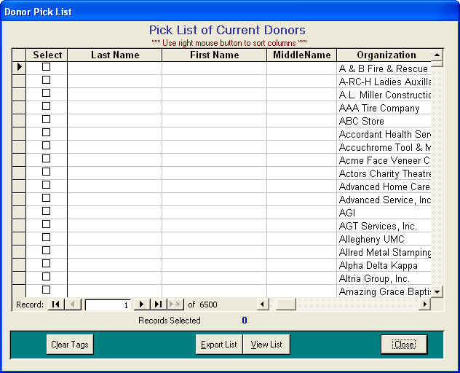
Browse Pick List: The Browse Pick List function is designed to allow the user the ability create a random mailing list from the donor database. Lets say that your director hands you a list of donor names that they would like to send an invitation to a special luncheon. The Browse Pick List function will allow you to view entire donor database and scroll down the list Selecting the names you would like to invite. Once the donors have been selected, 1) View the list or Print a report on the selected donors and 2) Export the List so the names can be merged into a Microsoft Word document and/or label or envelope.

That is the basic way to use the Browse Pick List function. But lets take it to the next level by using the Mouse Right Click Shortcut Menu. When you put the curser on the field column you want to work with and Click the Right Mouse Button, you get a shortcut menu that will allow you to 1) Sort a field, 2) Use the Find function, 3) Filter By Selection and 4) Remove Filter/Sort.
Sort: The Sort function will allow you to arrange that field in Ascending (A-Z) or Descending (Z-A) order to make it easy to locate a contact for selection.
Find: The Find function will allow you to click on the field you would like to find a record by, type in the search information (name, address,ect) and click Find First to locate a particular record in that field. If the first record is not the correct record, click Find Next until you locate the correct record.
Filter By Selection: The Filter By Selection function will allow the user to select a field, highlight the text you want to filter on (City Name, Zipcode, ect.), Right Click on the highlighted field, select Filter By Selection and the Browse Screen will display only records that fit that criteria. This could be very helpful for that special mailing or a quick report.
Remove Filter/Sort: The Remove Filter/Sort function will return the Browse Screen to the original state and remove any Sorting or Filters.
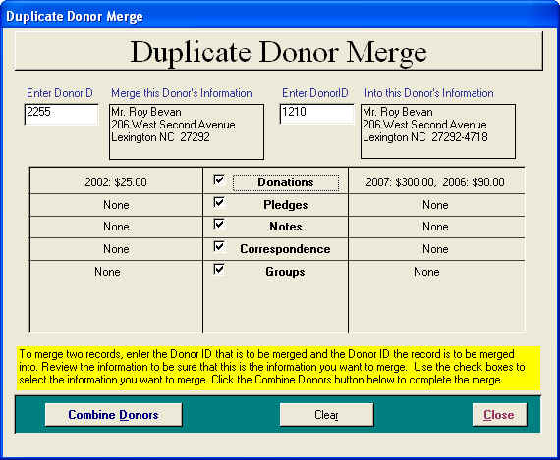
Donor Merge: The Donor Merge feature allows the user to manage duplicate donor records. To merge two records, enter the Donor ID that is to be merged and the Donor ID the record is to be merged into. Review the information to be sure that this is the information you want to merge. Use the check boxes to select the information you want to merge. Click the Combine Donors button below to complete the merge.

DonorExpress Custom Reports: Custom Reports is a Service offered to help the DonorExpress users with any special reporting needs they may have. There is a modest fee for this service but allows the user to meet special reporting requests.

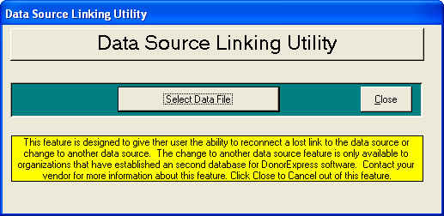
Data Source Linking Utility: The Data Source Linking Utility allows organizations using more than one database to change between the databases. When you select this feature, you will break the link to the current database and will then have the option to select a different data source.

Features on the Help Menu
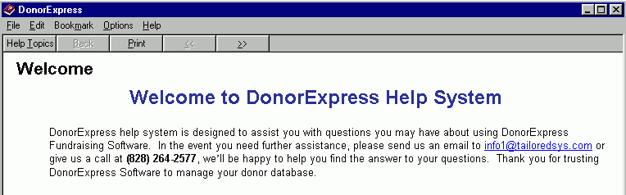

Donor Help System: The Donor Help System is the first place that a user can go to try to find answers to problems or procedures. The Help screen has a listing of topics on the left hand side and when the user clicks one of the topics a detail of that topic will appear on the right hand side. Answers and information to most technical problems can be found in the Help System.

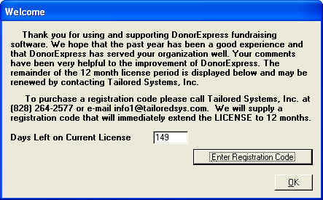
Registration: This is where users enter the their registration code for DonorExpress licensing. After contacting us at (828)264-2577 and receiving your unique registration code, select Enter Registration Code button. This process will extent your license for one year and entitles you to full support and any and all upgrades for DonorExpress as they become available. The remaining days on the DonorExpress license are displayed.
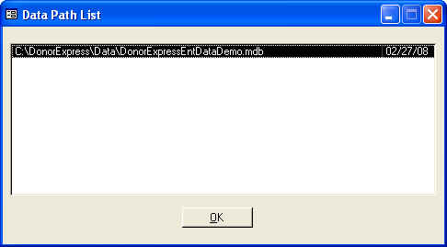
View Data Path: The View Data Path utility allows the user to see the path to the data file that they are currently linked to. The top path is the most current location of the data.

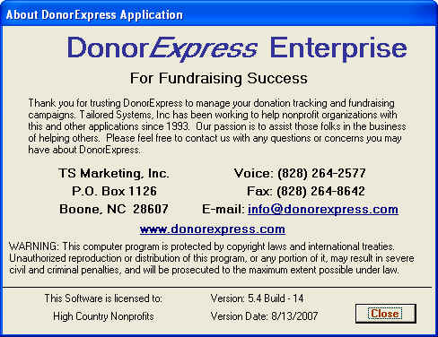
About DonorExpress: The About DonorExpress Screen gives the user information on the Version and Build Number of the software they are currently using. Also there is information on how to contact Tailored Systems, Inc. the creators of DonorExpress and the DonorExpress Customer Support Center.

